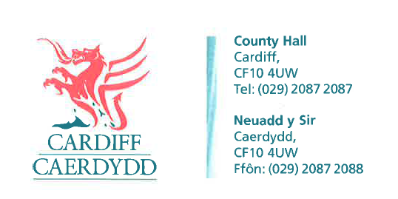
FOI Response Document
FOI12526
Thank you for your request under the Freedom of Information Act 2000 about School Payroll Systems received on 15/10/2018:
Request:
Please can you provide me with a list of all schools in your authority who have current live payroll facilities for supply teachers?
We have considered your request and enclose the following information:
Response/Exemptions:
Please see below table:
 | Academic Year
School | 2017/2018 | 2018/2019
BRYN DERI PRIMARY SCHOOL | YES | YES
BRYN HAFOD PRIMARY SCHOOL | YES | YES
CANTONIAN HIGH SCHOOL | YES | NO
CARDIFF WEST COMMUNITY HIGH SCHOOL | NO | YES
CHRIST THE KING RC SCHOOL | YES | YES
CORPUS CHRISTI HIGH SCHOOL | YES | NO
CORYTON PRIMARY SCHOOL | YES | YES
CREIGIAU PRIMARY SCHOOL | YES | YES
EASTERN HIGH SCHOOL | NO | YES
GRANGETOWN NURSERY SCHOOL | YES | NO
GREENHILL SCHOOL | YES | YES
HERBERT THOMPSON PRIMARY SCHOOL | YES | YES
HOLY FAMILY RC PRIMARY SCHOOL | YES | YES
LLANISHEN HIGH SCHOOL | YES | NO
MARLBOROUGH PRIMARY SCHOOL | NO | YES
MARY IMMACULATE HIGH SCHOOL | YES | NO
MEADOWBANK SCHOOL | YES | YES
MEADOWLANE PRIMARY SCHOOL | YES | YES
MILLBANK PRIMARY SCHOOL | YES | YES
MOORLAND PRIMARY SCHOOL | YES | NO
PENCAERAU PRIMARY SCHOOL | YES | NO
PENTYRCH PRIMARY SCHOOL | YES | NO
RADNOR PRIMARY SCHOOL | YES | NO
RADYR COMPREHENSIVE SCHOOL | NO | YES
RADYR PRIMARY SCHOOL | YES | YES
RHIWBINA PRIMARY SCHOOL | YES | NO
RIVERBANK SCHOOL | YES | YES
ST ILLTYDS HIGH SCHOOL | YES | NO
ST JOHN LLOYD RC PRIMARY | YES | YES
ST PATRICKS RC PRIMARY SCHOOL | YES | YES
ST PAULS CW PRIMARY SCHOOL | YES | NO
ST PETERS RC PRIMARY SCHOOL | YES | NO
ST PHILIP EVANS RC PRIMARY SCHOOL | YES | NO
ST TEILOS CW HIGH SCHOOL | YES | YES
THE HOLLIES SCHOOL | YES | YES
TREDEGARVILLE CW PRIMARY SCHOOL | YES | YES
TREMORFA NURSERY | YES | NO
TY GWYN SCHOOL | YES | YES
WHITCHURCH PRIMARY SCHOOL | YES | YES
WILLOWBROOK PRIMARY SCHOOL | YES | NO
WILLOWS HIGH SCHOOL | YES | NO
WOODLANDS HIGH SCHOOL | NO | YES
YSGOL BRO EIRWG | YES | YES
YSGOL GLAN CEUBAL | YES | YES
YSGOL GLAN MORFA | YES | YES
YSGOL GYFUN GYMRAEG BRO EDERN | YES | YES
YSGOL GYFUN GYMRAEG PLASMAWR | YES | YES
YSGOL GYMRAEG COED Y GOF | YES | NO
YSGOL GYMRAEG MELIN GRUFFYDD | YES | YES
YSGOL GYMRAEG PWLL COCH | YES | NO
YSGOL GYMRAEG TREGANNA | YES | YES
YSGOL GYNRADD GWAELOD Y GARTH PRIMARY SCHOOL | YES | YES
YSGOL MYNYDD BYCHAN | YES | NO
YSGOL PEN Y PIL | YES | YES
YSGOL PENCAE | YES | YES
YSGOL Y BERLLAN DEG | YES | YES
YSGOL Y WERN | YES | NO

If you have any queries or concerns, please do not hesitate to contact us.

Please remember to quote the reference number above in any future communications.

